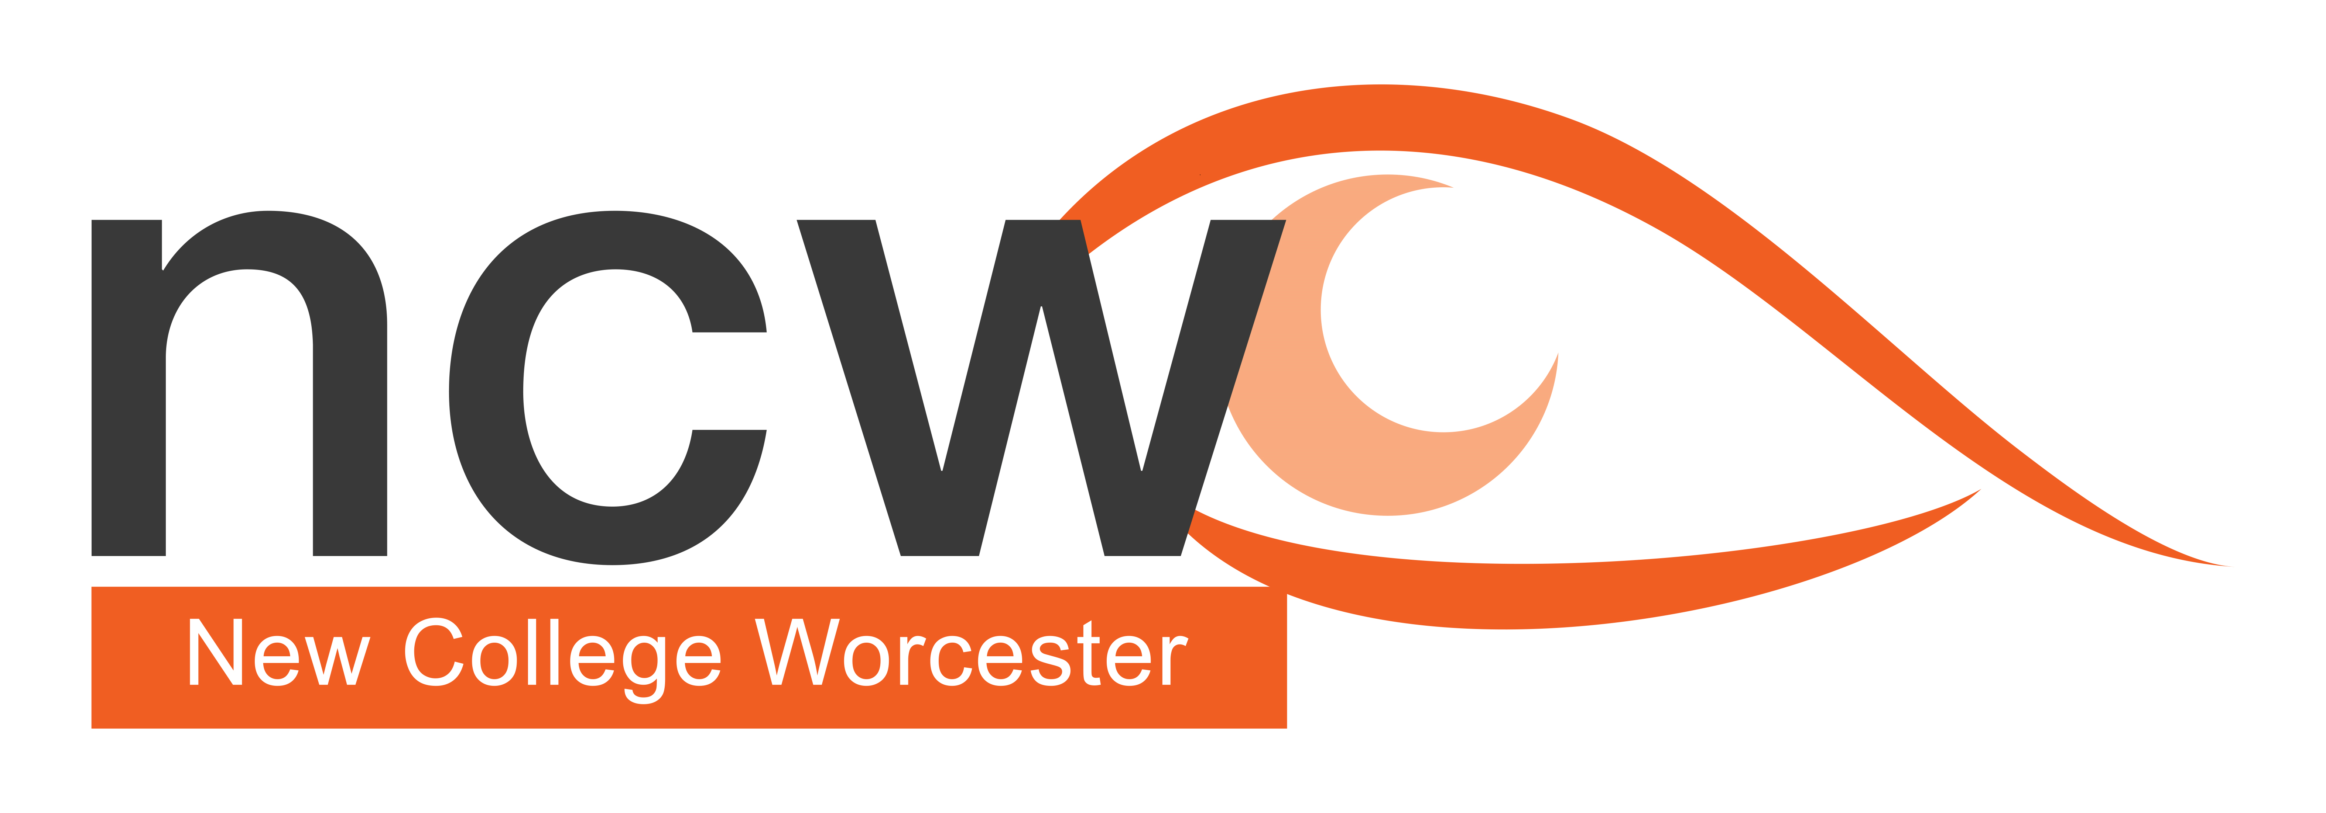No. 2 March 2021

Reaching out

**NCW Outreach Termly Bulletin — Supporting V.I. Education**

## In this issue:

* Supporting Remote Learning
* Supporting Mental Health and Emotional Well-being
* Upcoming courses
* Outreach Team profile

## **Supporting Remote Learning**

## 

## **1. Top Tips**

Be there – regular contact – make it as ‘normal’ as possible.

If working with groups make sure names are used and all involved.

On video calls, stay on line while students work to give time calls and support.

As in class, give time prompts; without this, some students get stuck and give up or take forever! If going off to work, provide a specific time to come back.

If students have more than one device use them all - for example phone for communication, braille note for writing; or camera on the phone to see any issues on laptop.

In subjects such as Music, get students to record themselves so that sharing their piece can be done away from the instrument.

## **2. Structure lessons**

Fun starter – e.g. post a joke on chat to join the lesson

Intro – lots of questions, introduce the content

Main – Discussion is great – it’s the same as at school except to remember turn taking!

Students to go off and work independently – could be watching YouTube clips, then answering questions. Supporting with email in case tech fails

Check learning – get students back together- they send work, scan thorough and ask them individual questions and go through any questions set or Role-playing, Quizzes, Games

Plenary – Can leave once they answer a verbal question correctly

Important tips – don’t talk for the whole lesson! Give students time to think! Give them time to work on their own! Give them time to talk!

Keep parents in the loop

Share your screen if watching a video – you can talk over it! Putting headphones in prevents echo.

Ask students what is working for them – some want a Word Doc, some like it in the body of an email, some use Google Docs

Use Headings

Keep to the point, avoid lots of text

Set up “math autocorrect” for symbols. This is essential!

Keep the same structure on every document so the students can concentrate on the content

### Additional materials:

For our Protocols to assist people with a VI presenting or accessing a remote Meeting or Lesson, follow this link: <https://www.ncw.co.uk/wp-content/uploads/2020/11/NCW-Protocols-for-remote-working-with-people-with-a-VI.docx>

For the next four weeks go to the Outreach page of the NCW website where podcasts linked to Remote Learning on relaxation techniques, PE, Mobility and ILS will be released: <https://www.ncw.co.uk/services/outreach-service/>

## **Strategies to promote Keeping Positive and balancing Wellbeing**

It is very easy for us all to fall into a pattern of low mood and isolation. This is even more so during this difficult time of Covid.

**Why is positive wellbeing important?**

Feelings of **wellbeing** are fundamental to the overall **health** of an individual, enabling them to successfully overcome difficulties and achieve what they want out of life. Past experiences, attitudes and outlook can all impact **wellbeing** as can physical or emotional trauma following specific incidents.

**Things we can tell our students to do to help them feel happier and healthier**

Smile daily, even laugh out loud - it’s the best medicine.

Communicate with at least one other person and try to make it a real conversation not by using technology. We all forget how to use the telephone and text instead, because we think it is easier.

Make time to do something nice for yourself every day, read a favourite book, have your favourite drink, wear your most comfortable clothing or make your favourite cake or meal.

Put on your favourite music and dance like no-one is watching

Go outside, breathe in the fresh air and walk

Whilst walking or outside, listen to the birds and sounds around you, smell and breathe the air. Listen for the signs of spring.

Achieve an act of kindness

Look for the positives as it is easy to find the negatives.

**Relaxation Technique**

Abdominal Breathing technique to help with stress and anxiety

1.Sit upright, elongate, lengthen your spine by creating a pulling up from the top of your head.

2.Ensure your shoulders are relaxed.

3.Put a hand on your stomach, over your belly button

4.Put a hand on your chest.

5.Breathe in through your nose and feel your stomach expand and rise, your chest should remain relatively still. Hold for 3 seconds.

6.Purse your lips and exhale out through your mouth. Try engaging your stomach muscles to push air out at the end of the breath.

For this type of breathing to become automatic you will need to practice it daily.

Try doing the exercise with 3 or 4 breaths and repeat 10 times per day.

If you have not been using your Diaphragm to breathe before you may initially feel tired and light headed at first, however it will get easier.

The benefits can include lower blood pressure and heart rate, lower tension and muscle pain, increased energy, mental health benefits and better sleep.

## **Upcoming free online courses**

Introduction to VoiceOver on the iphone - 2nd March, Twilight 3.30-5.00pm.

An introduction to VoiceOver, the screen reader on iPhones and iPads:

* How to turn VoiceOver on or off as a sighted or speech-using person
* Why your finger stops working properly with VoiceOver on, and how to interact with your screen with it running
* How to connect a Braille display (including a Braillenote) if you have one
* The various typing methods VoiceOver supports
* And you’ll receive a shortlist of accessible apps to get started as a visually-impaired iOS user.

Outreach Open Day 10th March, 10 am – 3pm

An informal day giving a taste of how NCW teaches students who are vision impaired. There is the opportunity to meet subject teachers, as well as gain practical support and advice on specific curriculum areas of your choice.

## **Who we are - NCW Outreach Team: Profile 2**

## **Joanne Hyde - Outreach Support Coordinator**

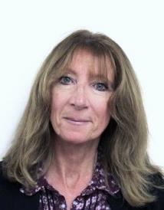

Jo is the outreach support co-ordinator responsible for organising the bookings and administration for the outreach events held by the college.

Jo started her working life as a solicitor in private practice where she spent 15 years, specialising in general litigation, family law and then administration of estates.

Following the birth of her third child in 2005, she decided to take a career break and volunteered with a local sight loss charity, Sight Concern. She joined NCW in 2013 as a member of the exam support team becoming a permanent member of the NCW community when she joined the administration team in 2015.

In her spare time she enjoys swimming and playing tennis and taking long walks with her cocker spaniel, Jasper. When she is not working in the garden, she likes to travel and has been compiling a list of places to visit once lockdown has eased. A little known fact – she holds awards for Latin American and ballroom dancing and in another life would be a professional dancer!

## 