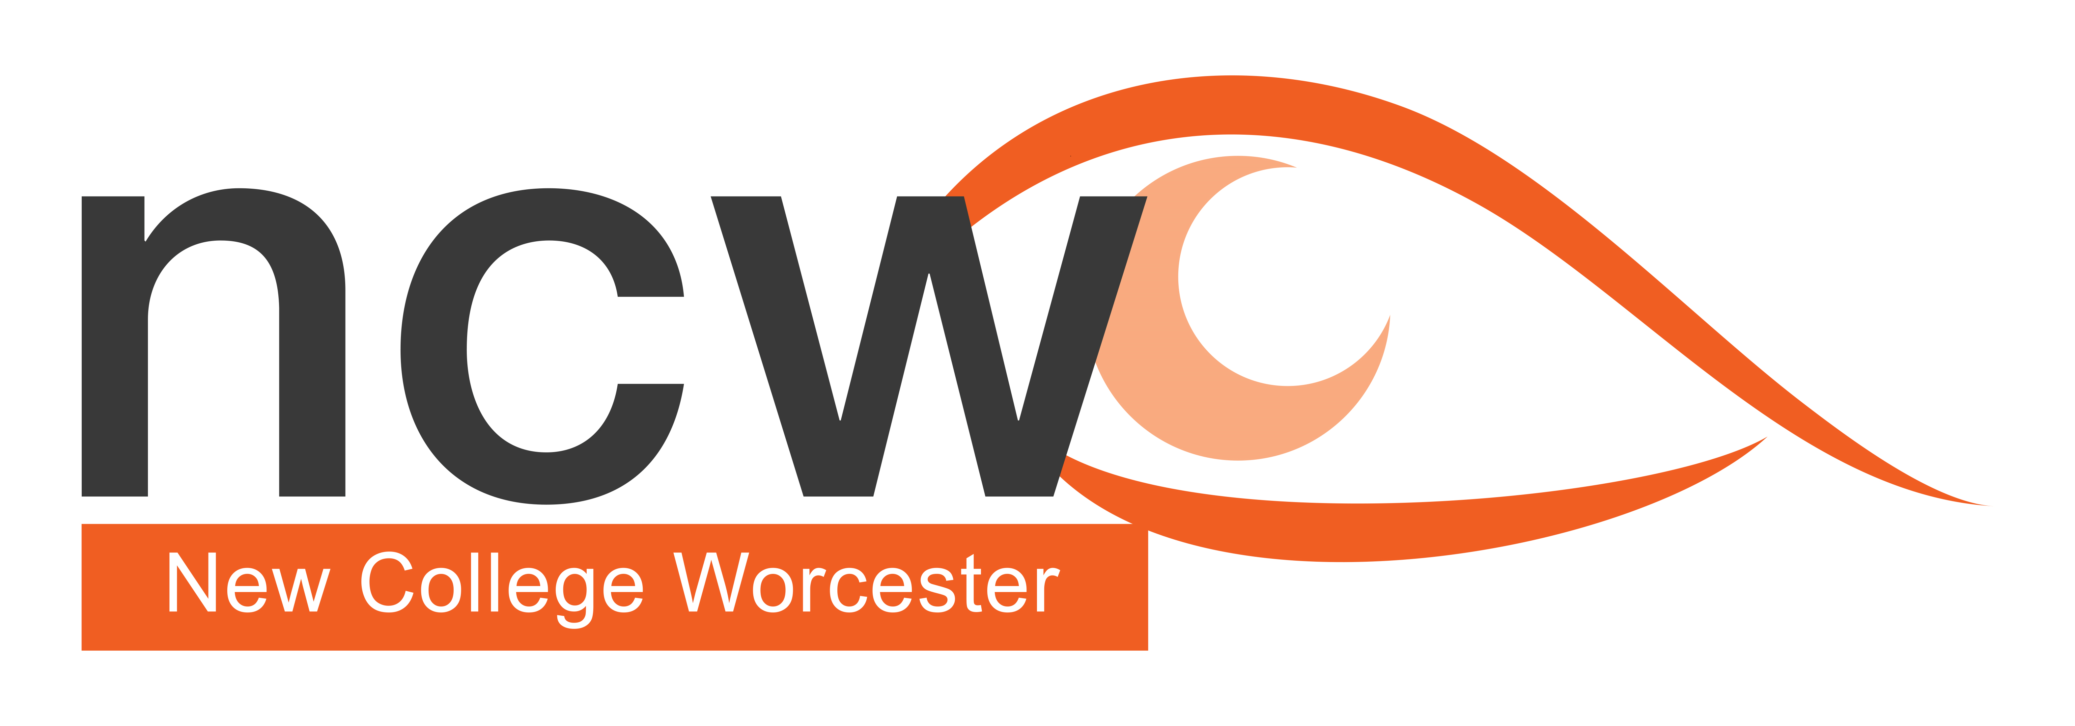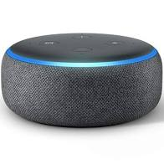No. 4

Figure 1 Photograph showing an Alexa Echo Dot

October 2021

Reaching out

**NCW Outreach Termly Bulletin — Supporting V.I. Education**

## In this issue:

## Encouraging Movement and Activity

## Top Tips for PE Lessons

## Useful Contacts for Sporting Activities

* Upcoming Courses
* Outreach Team Profile

## **Encouraging Movement and Exercise**

As we emerge from the restrictions of the pandemic we may be looking to return to activity or realising how important activity is for our physical, mental and social wellbeing, looking to start an activity that is accessible.

The type of activity we are looking for will depend on many factors, including location, age of participant, access to transport and cost.

School based activities are convenient in terms of location but sometimes not accessible in the first instance. PE lessons that have the flexibility to be accessible to the student with a visual impairment are worth their weight in gold. This is especially true in the early years when children are developing the fundamental movement patterns such as running jumping and spatial awareness. Scaffolded support can achieve this, giving the child early mastery and confidence to work at the edge of their comfort zones when facing new challenges.

**Top Tips for Assisting in PE Lessons**

* If using the same space (e.g. sports hall or school dining hall) for P.E., give the child the opportunity for orientation when quiet. Name the boundaries of the working area with different names so they know where they are in the space.
* If possible use string under tape to add tactile reference on the floor for activities where squaring up is needed before they start: this is especially important if the student can’t use a wall or fence to locate themselves.
* The student position should be on the edge of the class to minimise the noise around them.
* Get the class teacher to stay in the same place when giving instructions.
* Build a new skill on previously learnt skills.
* Use references to movements known to the child, e.g. they may not know what a plane looks like if you want them to put their arms out horizontally from their shoulders.
* Early success will bring confidence, so scaffold to ensure early success.
* Remember S.T.E.P. (Space, Task, Equipment, People); alter one or more component to assist with aiding success.
* Try to introduce directional instructions in young children early, but repeat consistently to embed, e.g. left, right, forward, backwards, under, over.
* Teach young children body parts and use with directional to aid movement pattern development e.g. hands together, left foot forward
* Class warm-ups don’t have to be running around the field. Encourage class to use warm-up activities that can be done “on-the-spot”, e.g. star-jumps, heel flicks, knees up, squats, lunges.
* Use audible balls where applicable.
* For safety discuss with teacher use of whistle for “freeze” or stop only. Remember to carry your whistle on staff lanyard.

(See below for useful sporting contacts)

## **Courses in the Autumn term**

**Teenage Tips: Living Skills for a VI Teenager - Wednesday 10th November 2021 Free online course**

Do you have a Teenage dirt bag?

All children and young people at some time need a push in the right direction when it comes to looking after their own personal hygiene.  The only positive of Covid is that we all now know how to wash our hands properly.  This seminar will look at some simple methods to help you empower your pre-teen to shower effectively, brush their teeth and explore strategies for making sure they are clean and presented well.

**Outreach Open Day Wednesday 17th November, 10 am – 3pm Cost £80** (to include lunch and refreshments)

These informal days are for education professionals who are supporting a student who is vision impaired or parents of a VI child and will give a taste of how NCW teaches students who are VI.  
There is the opportunity to meet subject teachers, as well as gain practical support and advice on specific curriculum areas of your choice. included in the cost of the day one of the charged NCW outreach courses per school year.

**Looking ahead - GCSE Revision Course (6th - 8th April 2022)**

We are planning to hold the GCSE Revision course on site next Easter, (Wednesday 6th to Friday 8th April) for the first time in 2 years. The course is suitable for all VI students in Years 9, 10 and 11 to help them with their revision skills and exam technique. The course is residential and there is the opportunity in the evening to socialise with their peers and have some fun.

## **NCW Outreach Team Profile 4**

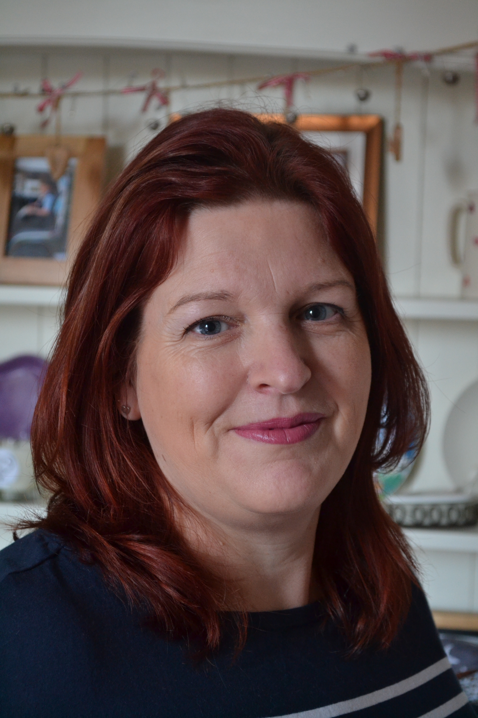Nathalie Emanuel is Strategic Lead for Independent Living Skills and Assistant SENCo. at NCW.  Her main role as Strategic Lead is to ensure that each student is taught ILS and has a waking day curriculum which meets their EHCP needs.

Nathalie’s career started as a product development technologist; she has worked for numerous companies developing a range of fruit preparations for Muller Corners and developed Iceland Breaded Chicken, as well as working with Sainsburys to revamp their pot desserts range when they left the dessert giant St Ivel.

A light bulb moment occurred as she drove home from work one night after a very early morning factory trial, that she wanted to share her passion and enable others to follow in her footsteps in the exciting food manufacture world.  She enrolled at University for a PGCE and taught GCSE and A Level Food Technology at a mainstream school. After having a family and working part time, Nathalie saw an advertisement for a Home Economics teacher at NCW and thought that it sounded interesting but a bit old- fashioned.  She joined the team at NCW in January 2012 and quickly brought the department up to speed with new courses and ways of working.

In her spare time, she enjoys working in the garden and growing seeds.   Nathalie loves the sea and nature walks and is often found walking along the river bank and visiting Croome Park.  Nathalie is looking forward to travelling once her children are older and do not want to go with her!

## **Useful Contacts for Sporting Activities**

There are a wide range of organizations working to provide opportunities for children with a VI. Whilst some of the bigger organisations have paid staff, many of these people are unpaid angels, whose passion for accessible sports and activities can’t be underestimated.

The first group of organisations are good for information about activities that are available and also for signposting to other organisations providing activities:

* British Blind Sport <https://britishblindsport.org.uk/> provides access to sports and recreations as well as educational information for those working with sportspeople with a VI.
* VICTA <https://www.victa.org.uk/> A multifaceted organisation that provides a wide range of activities opportunities and funding for under 29 year olds and their families.
* Metro Blind Sport <https://www.metroblindsport.org/> They are London based but have a wide range of activities from audio exercise programmes, athletics and archery to sailing, skiing and walking

There are a wide range of organisations providing sport specific opportunities such as:

Cricket <http://www.bcew.co.uk/> Blind Cricket England and Wales information on locating a club near you and all the information you may need.

Goalball <https://goalballuk.com/> GoalballUK information on locating a club near you and also have staff that can bring Goalball to your school.

Football <https://www.englandfootball.com/play/disability-football> Useful information -scroll down to “Find Football Near You” for club locator.

Golf <https://ewblindgolf.co.uk/>

Boccia <https://www.bocciaengland.org.uk/vi-boccia> Following the Boccia success at the Tokyo Paralympics, this website is the place to start if you feel you need to know more.

Judo <https://www.britishjudo.org.uk/gb-judo/gb-world-class-performance-programme/gb-olympic-and-paralympic-programme/>

Rowing <https://www.britishrowing.org/para/> As their slogan says “Not for Everyone” but if you are not afraid of hard work and early starts then rowing may be for you. Indoor rowing information can also be found on the British Rowing website; this is a brilliant activity for general fitness through to high level competitions.

Athletics <https://www.uka.org.uk/get-involved/> Many athletic events are very assessible without much adaptation needed. If you have a child with the desire to run, jump or throw, this is the website for you.

Cycling <https://www.britishcycling.org.uk/disability/article/20150812-disability-static-content-About-para-cycling-0> Again following the success at the Tokyo Paralympics, you can gain more information on everything from recreational to Paralympic performance pathways.

If you are looking to explore local areas by bike, and have a family member or friend to pilot you but don’t have a tandem cycle, try Charlotte’s Tandems.<http://charlottestandems.weebly.com/>

Triathlon <https://www.britishtriathlon.org/get-involved/paratriathlon> For those that can’t decide what sport to do, why not do 3!

And if you aren’t able to get to an activity maybe try one of the audio described exercise or yoga sessions provided by Eyes Free Exercise. These can be accessed through the Metro Blind Sport website.

## This list is just a taste of what is available. If you know of an organisation that you think needs sharing with the VI community please email [jprice@ncw.co.uk](mailto:jprice@ncw.co.uk)

## 

